**CHAPTER- 1**

**INTRODUCTION**

The project titled “Food Ordering System” is an application which will help restaurant to optimized and control over their restaurant. It is making the life of waiters easier because they don’t have to go to kitchen and give the orders to chef manually. For the management point of view, the manager (Admin) will able to control the restaurant by having all the reports to hand and able to see the records of each employees and orders.

This application helps the restaurants to do all functionalities more accurately and faster way. Food Ordering System manually works and improves efficiency of restaurant. This application contains functionalities, like:

* To store records.
* Control orders and service.
* Sales.
* Helps Admin to see each user’s orders.

The main goal is to maintain the restaurant’s function is an effective and accurate manner and also it is reducing the use of manual entries. This software helps food orders to maintain day to day records in system. It is keeping a proper record of the database.

**1.1 DESCRIPTION**

Food Ordering System is an application which refers to online systems which are generally small or medium in size. Food Ordering aims to save trees by letting you manage ordering on a computer and, lets the managers (Admin) keep track of regular customers.

The user interface is pretty plain but it is interactive and easy to navigate even without the help feature. We were able to jump right in and quickly become a user of this system.

All these help the peoples to manage the time with more convenience in a more efficient way.

**1.2 MOTIVATION**

The motivation for designing this application came because my family is involved in the fast food business and I personally do not like waiting for long in the hotels or to have to call hotel to place an order especially during the peak lunch or dinner hours. The languages used to build this application are JavaScript, CSS, HTML and PHP at client facing whereas SQL database at the back-end because I found them to be extremely useful while working on the technologies.

**1.3 OBJECTIVES**

* + 1. **General objectives**
* To increase efficiency and improve services provided to the customer through better application of technology in daily operations.
* To be able to stand out from competitors in food service industry.
* To enable customers to order custom meals that aren’t in the menu.
* To enable customers to have a visual confirmation that order was placed correctly.
* To reduce restaurant’s food wastage.
* Eliminate paper work and increase level of accuracy.
* Increase speed of service, sales volume and customer satisfaction.

**CHAPTER- 2**

**SCHEMA & ER DIAGRAM**

**2.1 SCHEMA**

SIGN UP (username, password, email, name, phno, address)

MENU (fname, fid ,fqty, fprice)

USERS (username, name, phno, address)

ADMIN (id, password)

SALES (username, fid, qty, total)

**2.2 SCHEMA DIAGRAM**

**SIGN_UP**

|  |  |  |  |  |  |
| --- | --- | --- | --- | --- | --- |
| Username | Password | Email | Name | Phno | Address |

**MENU**

|  |  |  |  |
| --- | --- | --- | --- |
| Fname | Fid | Fqty | Fprice |

**USERS**

|  |  |  |  |
| --- | --- | --- | --- |
| Username | Name | Phno | Address |

**ADMIN**

|  |  |
| --- | --- |
| ID | Password |

**SALES**

|  |  |  |  |
| --- | --- | --- | --- |
| Username | Fid | qty | total |

**2.3 ER DIAGRAM**

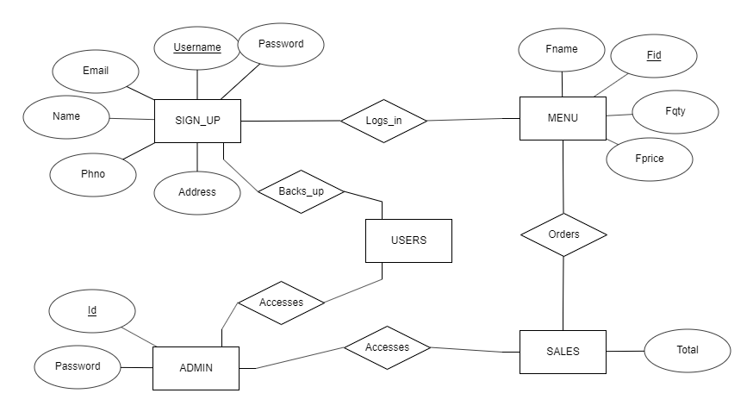

**CHAPTER- 3**

**SYSTEM DESIGN**

**3.1 DESCRIPTION OF THE PROJECT**

A fast food restaurant also known as quick service restaurant (QSR) within the foodservice industry is a specific type of restaurant characterized both by its fast food cuisine and by minimal table service. Food served in fast food restaurants is offered from a limited menu cooked in bulk in advance and kept hot, is finished and packaged for order and is usually available ready for pickup or to be delivered though seating may also be provided. The customers presently spend an average of 60 minutes per day going to the restaurant, selecting their meals and paying. Some restaurants have the provision of customers making a call to the restaurant in advance to order a meal to be ready for them for pick or to be delivered to them.

Some of the customers don’t always get the selection they want because the restaurants run out of certain items or because there is no provision of ordering custom meals. This project is aimed at developing a complete online ordering system for use in the foodservice industry which will allow the restaurants to quickly and easily manage an online menu which customer can browse and use to place orders with just a few clicks. The customers will have to choose whether they want the food to be delivered to them or it will be packaged for pick up and the payment method will be upon delivery or pick up. There will be a system administrator who will have the right to add and manage user accounts, a manager who will be managing product and orders and last but not least a meal deliverer who will be dealing specifically with pending deliveries. The customer will be in a position to view the products ,register and place an order. There will be a confirmation receipt for each and every order made by the customer which can be printed. The development of this system will be based on SDLC with PHP and HTML as the programming languages while MySQL server as the database of the system. HTML language is advantageous due to its easy to use and learn validation properties while MySQL has better advanced features and properties, has good security, is open source and has cross platform operability. The advantages of using PHP programming language in developing this system include:

• It is a stable open source language developed and maintained by a large group of PHP developers which help in creating a support community and abundant extension library.

• It’s easy and quick to learn and use.

• Can be run on many platforms thus easy for users to find hosting service.

• It has built-in database connection modules which makes it easy to connect to the database. On the other hand, the disadvantage of PHP programming language is security since it is open sourced, so all people can see the source code and if there are bugs in the source code, it can be used by people to explore the weakness of PHP

**3.2 LIST OF TABLES**

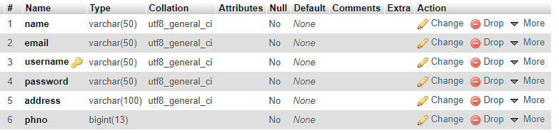

**Fig 3.2.1 Signup**

The Fig 3.3.1 is about ‘Signup’ which has the attributes name, email , password, username, address & phno where USERNAME is the primary key of the table. From this table, we can get the information about users registered.

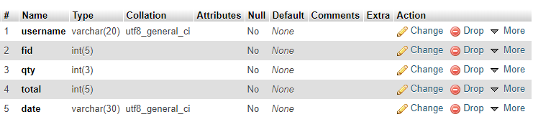

**Fig 3.2.2 Sales**

The Fig 3.2.2 is about ‘Sales’ which has the attributes, username, fid, qty, total. From this table, an admin is able to see the sales or orders of the customers. There is no primary key in the SALES table because a user can order many times.

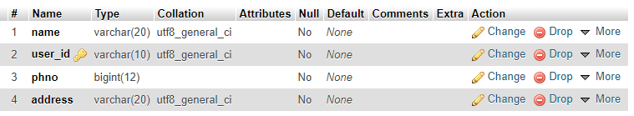

**Fig 3.2.3 Users**

The Fig 3.2.3 is about ‘Users’ which has the attributes name, user_id, phno, address where user id (username) is the primary key.

This table acts as a user backup table which can be only viewed by the ADMIN.

Items are inserted into this table as soon as a new user signs up, using a trigger.

.

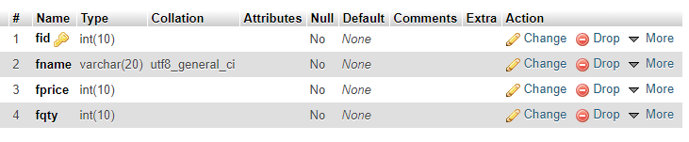 **Fig 3.2.4 Menu**

The Fig 3.2.4 is about ‘Menu’ which has the attributes fid, fname, fprice & fqty in which, fid is the primary key.

From this table, it is possible to retrieve the items in menu so that users can order food of their choice from the available items in menu.

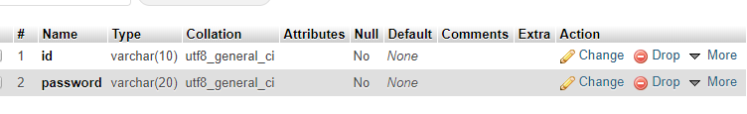

**Fig 3.2.5 Admin**

The Fig 3.2.5 is about ‘Admin’ which has the attributes id, password in which, there is no primary key as there is only one admin.

From this table, we can retrieve the information about an admin who logs in and receives the orders of the users(customers).

**CHAPTER- 4**

**SYSTEM SPECIFICATION**

**4.1 HARDWARE SPECIFICATION:**

**Processor:**Intel Core or above

**RAM:**Minimum 512Mb

**Hard disk:**10Gb or above

**4.2 SOFTWARE SPECIFICATION:**

**Front End:**HTML, CSS, PHP

**Back End:** SQL DATABASE

**Operating system:**Windows XP/7 or Higher

**CHAPTER- 5**

**ANALYSIS AND REQUIREMENTS**

**5.1 MYSQL DATABASE SERVER**

What is a database? Quite simply, it’s an organized collection of data. A database management system (DBMS) such as Access, FileMaker Pro, Oracle or SQL Server provides you with the software tools you need to organize the data in a flexible manner. It includes facility to add, modify or delete data from the database, ask questions (or queries) about the data stored in database and produce reports summarizing selected contents.

MySQL is a multithreaded, multi-user SQL database management system (DBMS). The basic program runs as a server providing multi-user access to a number of databases. Originally financed in a similar fashion to the jobs model, MySQL was owned and sponsored by a single for-profit firm, the Swedish company MySQL now a subsidiary of Sun Microsystem, which holds the copyright to most of the codebase. The project’s source code is available under terms of the GNU General Public License, as well as under a variety of proprietary agreements.

**5.2 APACHE**

The apache HTTP server is a web server software notable for playing a key role in the initial growth of the world wide web. In 2009, it became the first web server software to surpass the 100 million website milestone. Apache is developed and maintained by an open community of developers under the auspices of the Apache Software Foundation. Since April 1996 apache has been the most popular HTTP server software in use.

**CHAPTER- 6**

**IMPLEMENTATION**

**6.1 TRIGGER**

A trigger is a special kind of stored procedure that automatically execute when an event occurs in the database server.

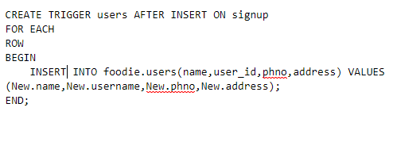

Here trigger is used to automatically update the users table when a new user is added.

**6.2 STORED PROCEDURE**

A stored procedure is a set of Structured Query Language(SQL) statements with an signed name which are stored in a relational database management system .

This procedure when called will give the details of the current user who is logged in and has an existing session.

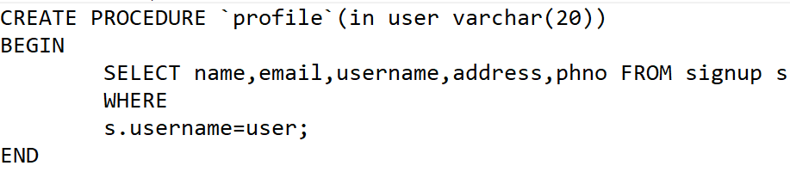

**CHAPTER-7**

**RESULTS AND SCREENSHOTS**

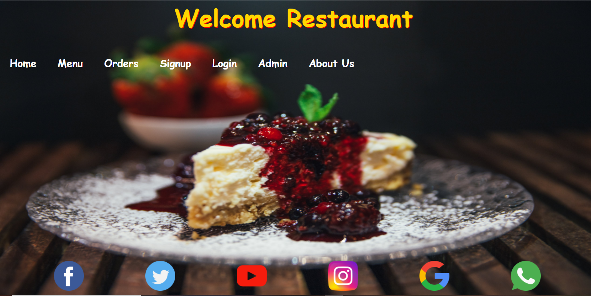

**Fig 7.1 Home page**

The Fig 7.1 is the home page of the Food Ordering System which contains a navigation bar that has HOME, MENU, MY ORDERS, SIGNUP, LOGIN, ADMIN, ABOUT US and LOGOUT. It also contains a Scrolling text called WELCOME TO FOODIES. This home page is a webpage that serves as the starting point of website of Food Ordering System.

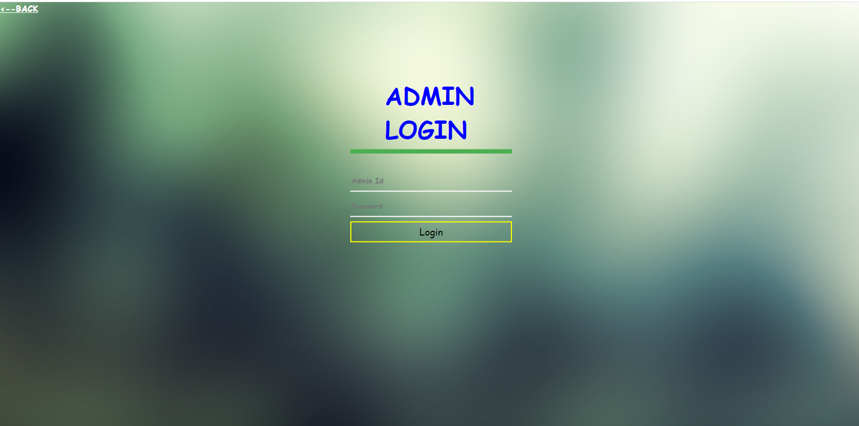

**Fig 7.2 Admin login**

The Fig 7.2 is the admin login page of the Food Ordering System in which an admin can login by entering his admin id and password. An admin does the duties of

* Receiving the orders of the customers.
* Counting the sales of the day.
* Managing the details of the users in case of any urgency.

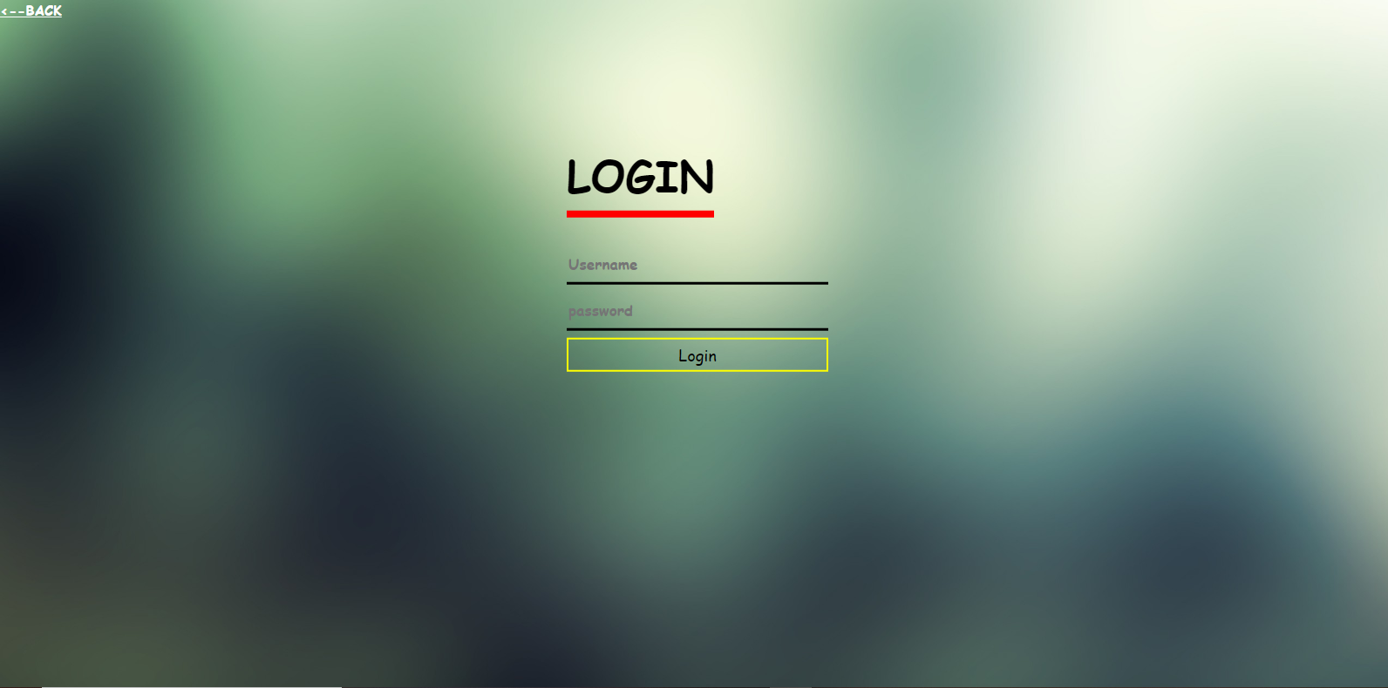

**Fig 7.3 Member login**

The Fig 7.3 is the member login page of the Food Ordering website where a member can login to order the available food in the Menu.

In this project, we have provided a facility for registering new members who are willing to have food at their place.

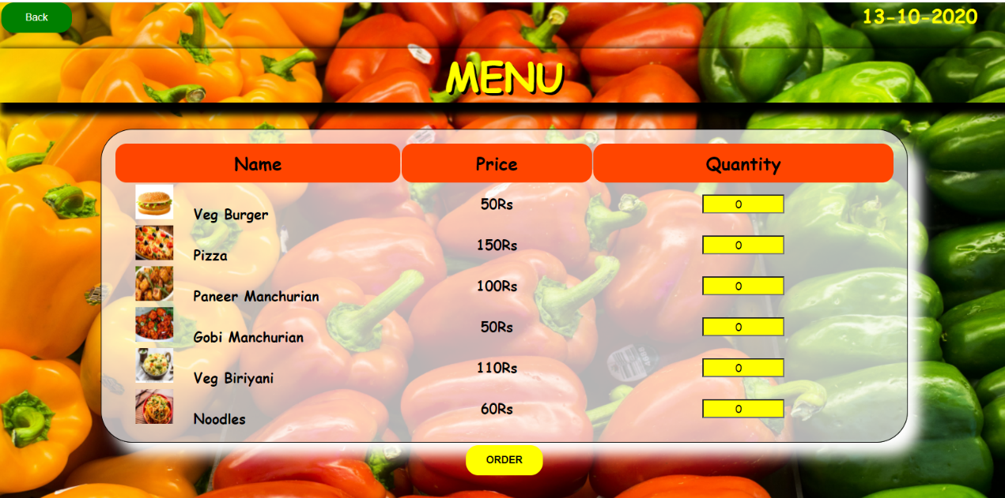

**Fig. 7.4 Menu**

The Fig 7.4 is the Menu which displays the available food in the menu with each item having details of Name, Price and Quantity.

The Quantity for the items can be chosen by the user as per their choice.

**CONCLUSION**

This is a computerized version of Food Ordering system which will benefit the people as well as the staff of the restaurants. In this entire process, one can search foods & order the food of their choice. The software takes care of all the requirements of a customer and is capable to provide easy and effective storage of information related to users. There is a future scope of this facility that all the things in future are going to be used online. A feature of ordering food where people can get the foods where ever they want and it’s a very efficient system for the people

**REFERENCE**

[1] Database System Model, Languages, Design and Application Programming, Ramez Elmasri and Shamkant B. Navathe, 7th edition, 2017, Pearson.

[2] Database Management System, Ramkrishnan, and Gehrke, 3rd edition, 2014, Mc-GrawHill.